**Docker Installation and Deployment**

1. Connect to AWS EC2 Instance (ap-south-1 : Mumbai).

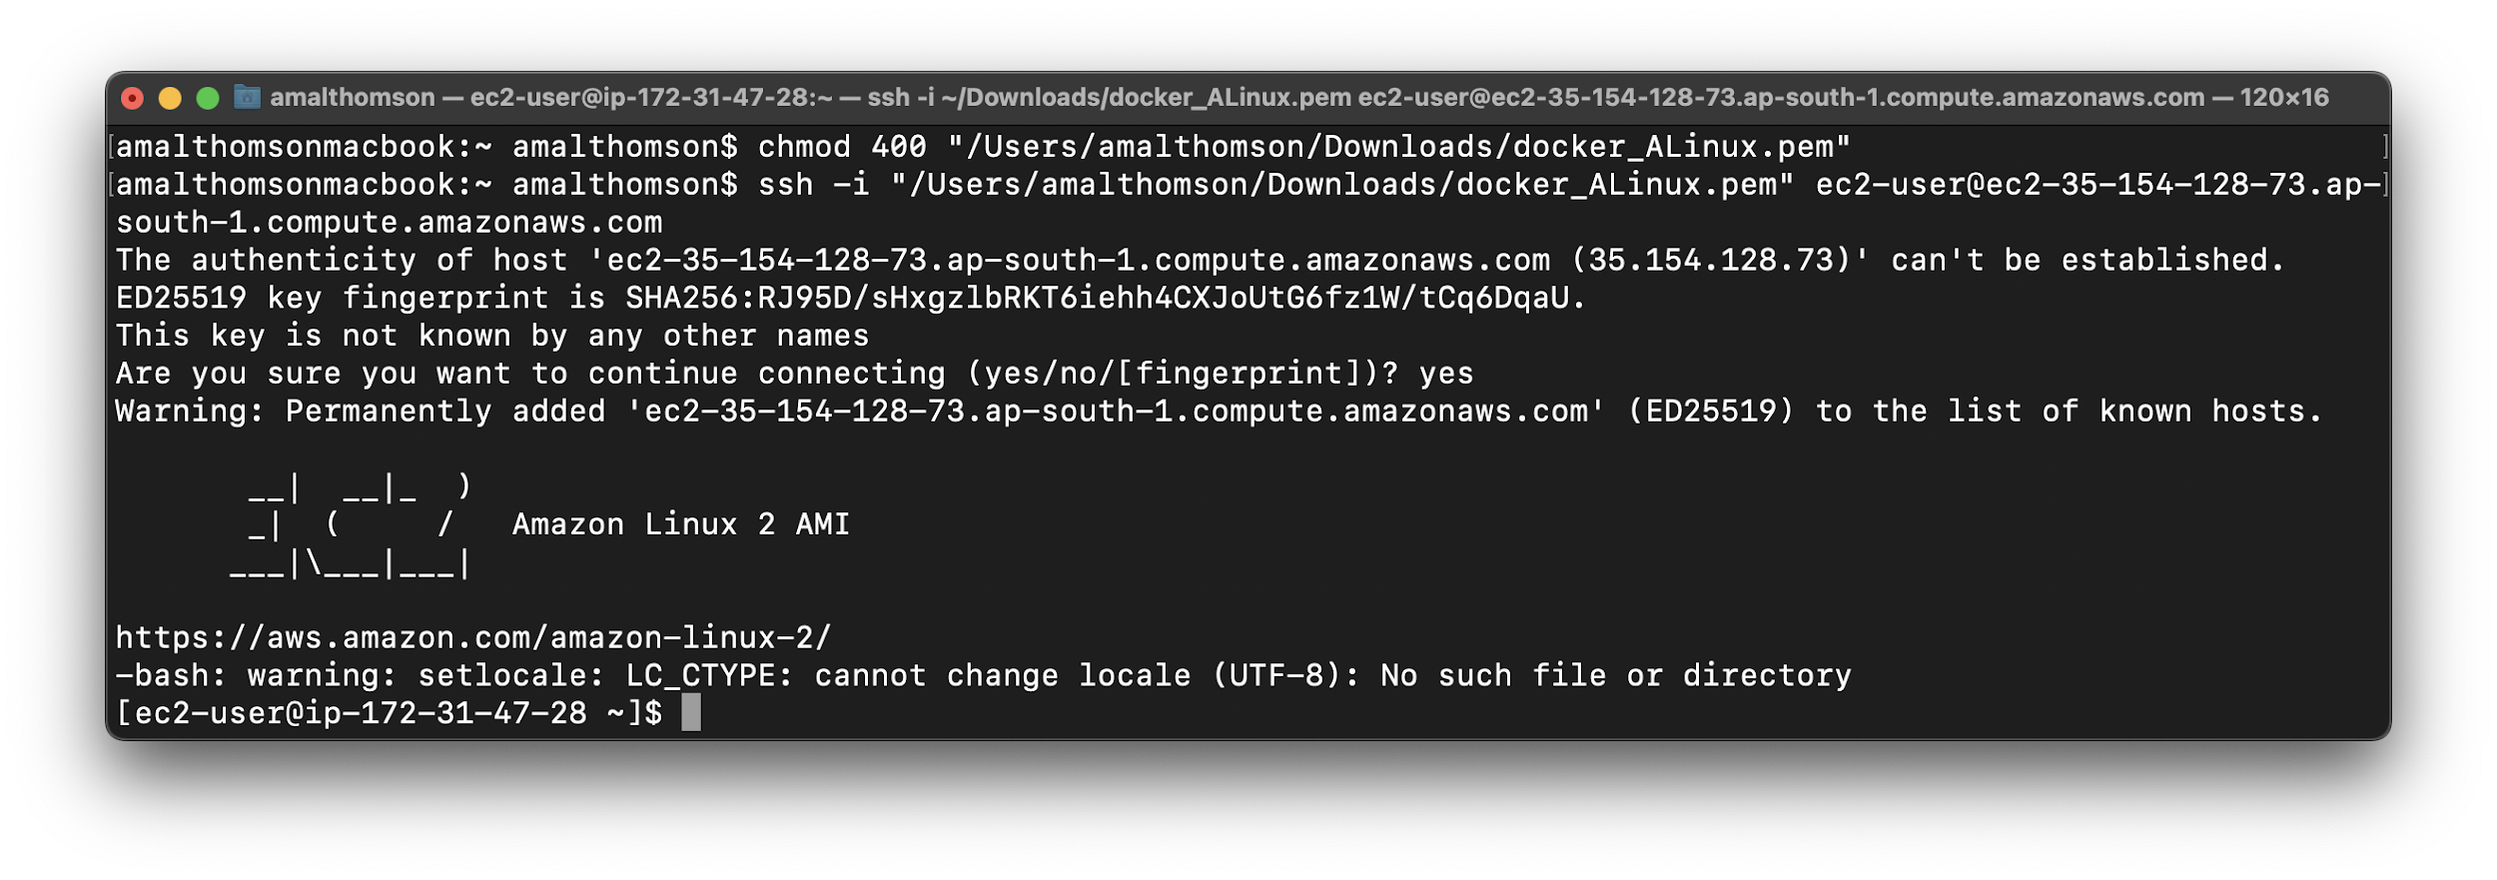

1. Docker Installation

*$ sudo su*

*# yum install docker -y*

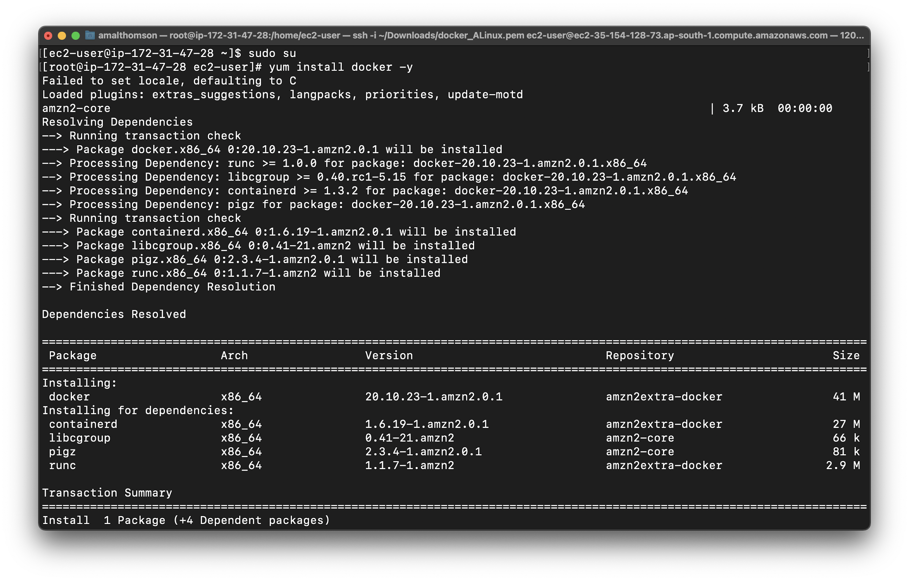

1. Docker Version

*# docker --version*

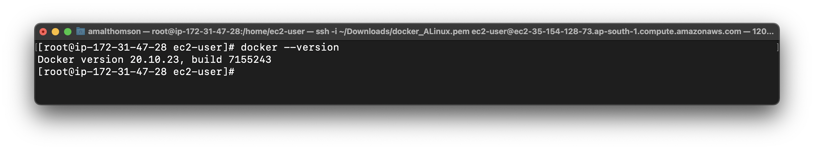

1. Docker Path

*# which docker*

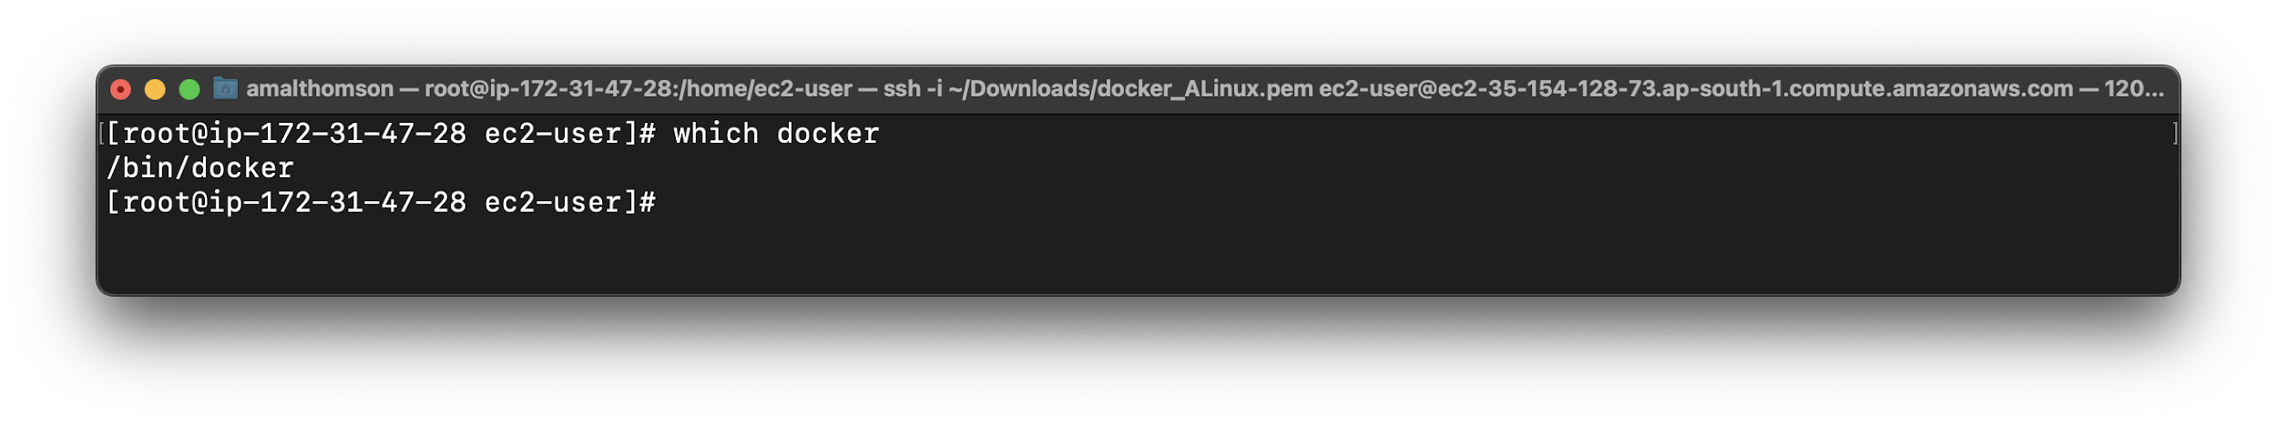

1. Start Docker service

*# service docker start*

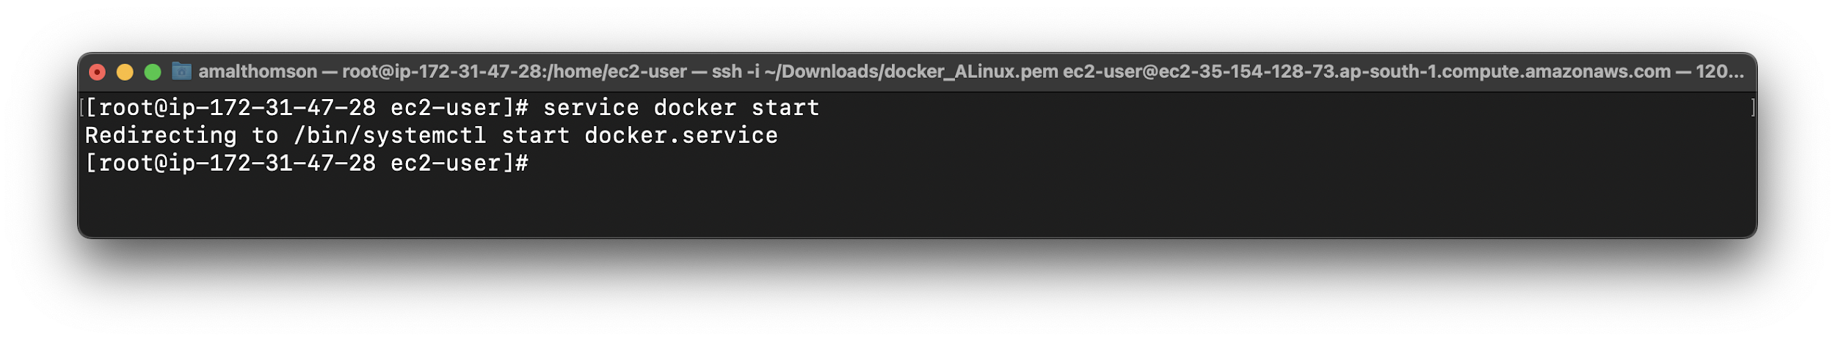

1. Check Docker status

*# service docker status*

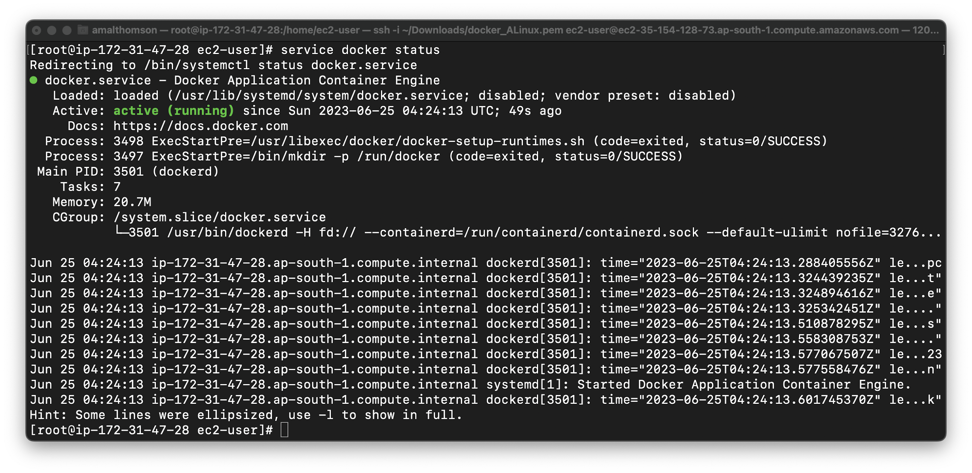

1. Display Docker images

*# docker images*

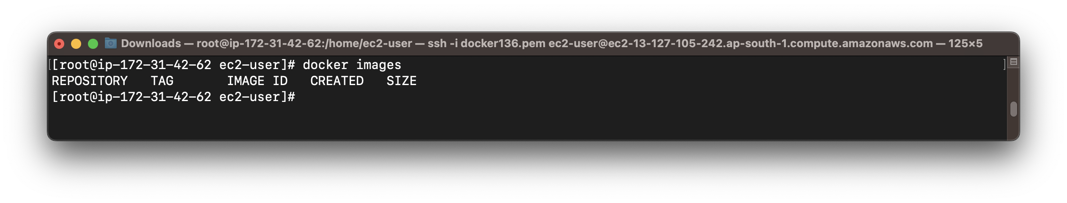

1. Pull a Docker Image from DockerHub

*# docker pull ubuntu*

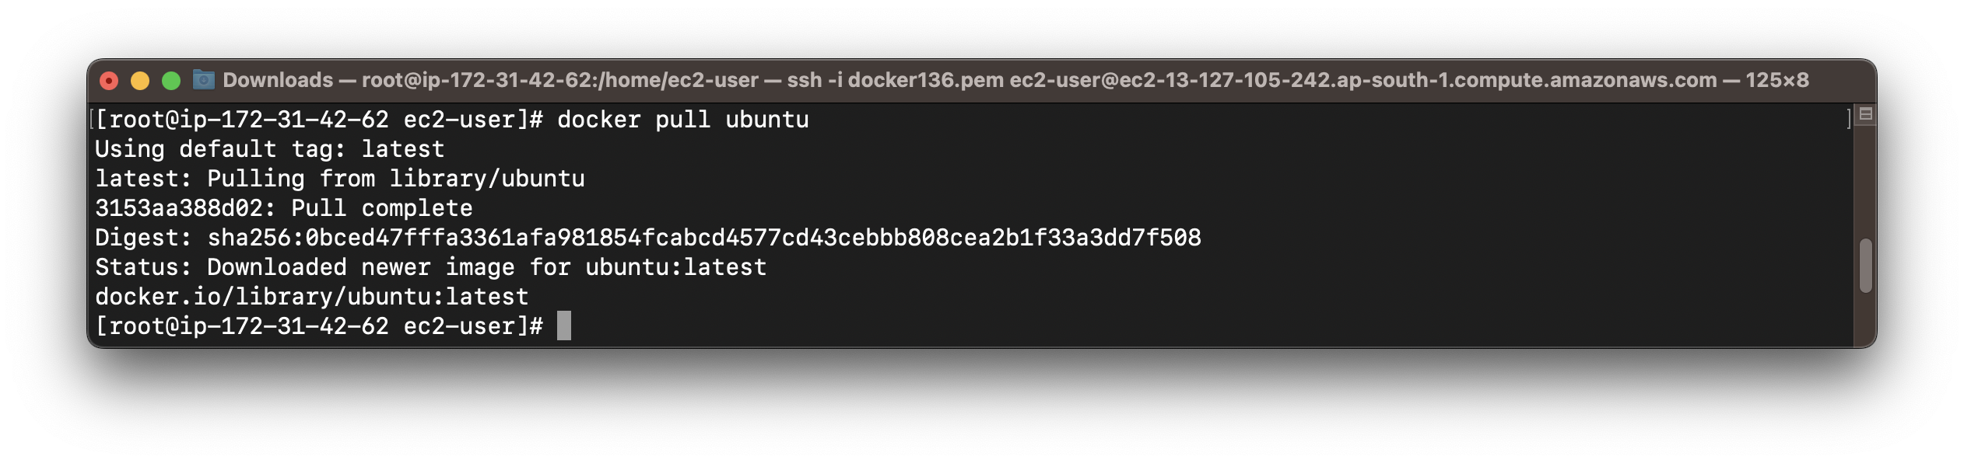

1. Display Docker Images

*#docker images*

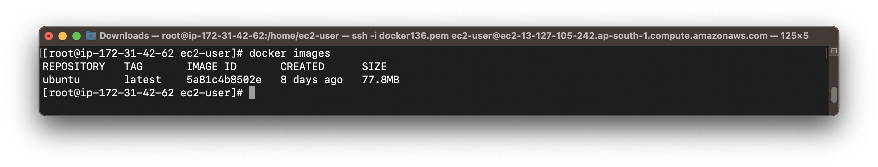

1. Run docker image

*# docker run ubuntu*

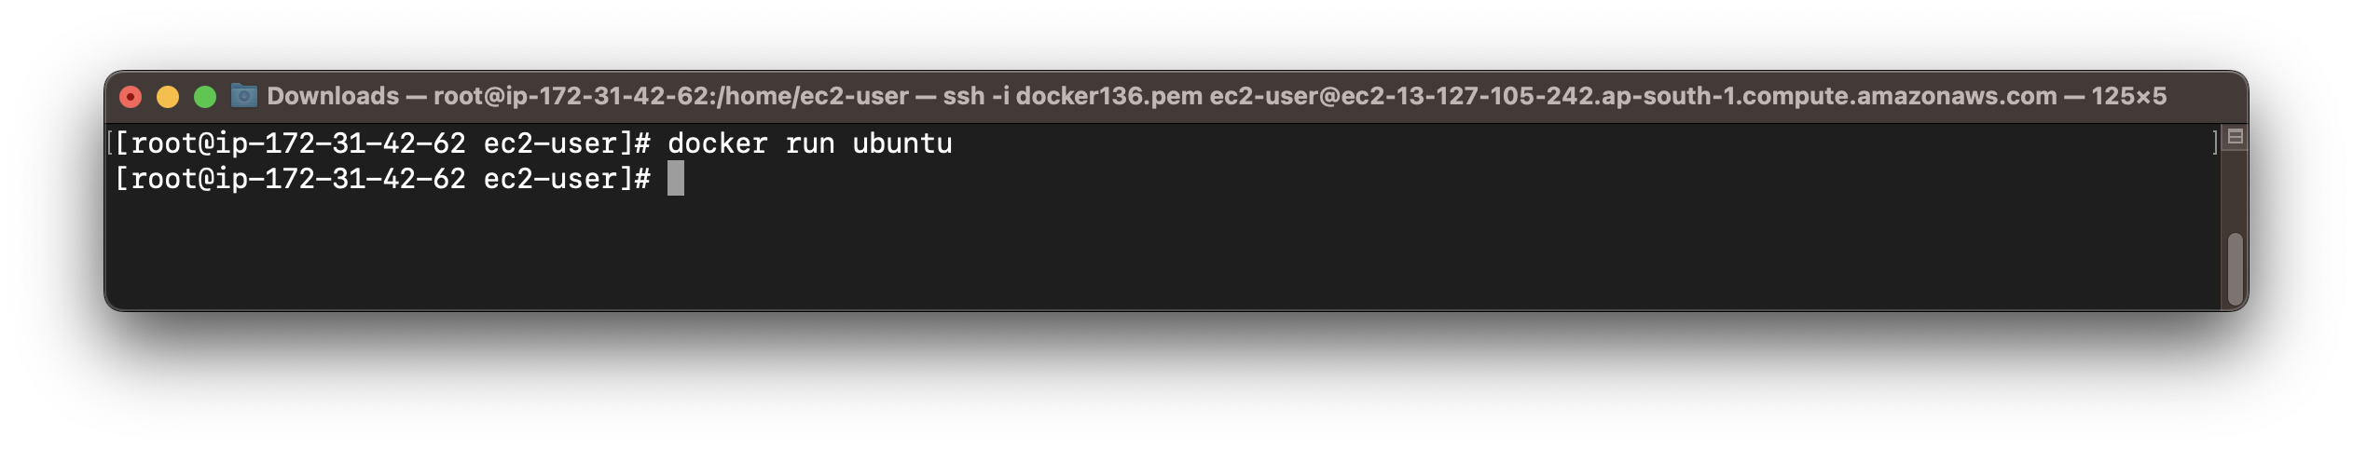

1. Display Process Status of Docker

*# docker ps -a*

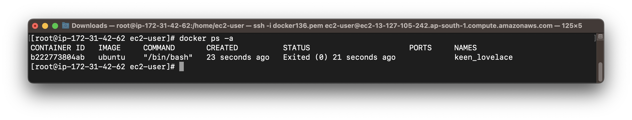

1. Pull and Run an interactive Container with custom naming the Container

*# docker run -it --name demoUBU ubuntu /bin/bash*

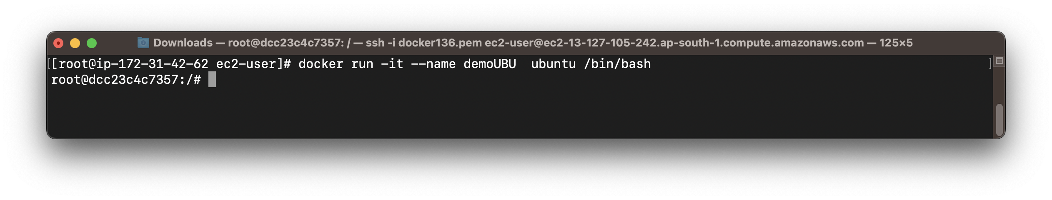

1. Display Process Status of Docker

*# docker ps -a*

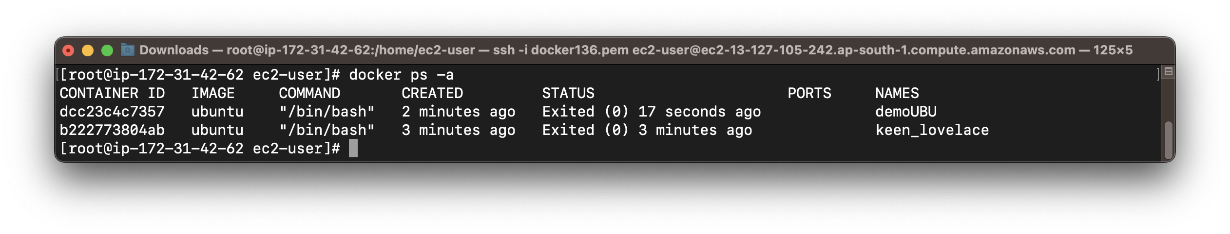

1. Start Docker

*# docker start demoUBU*

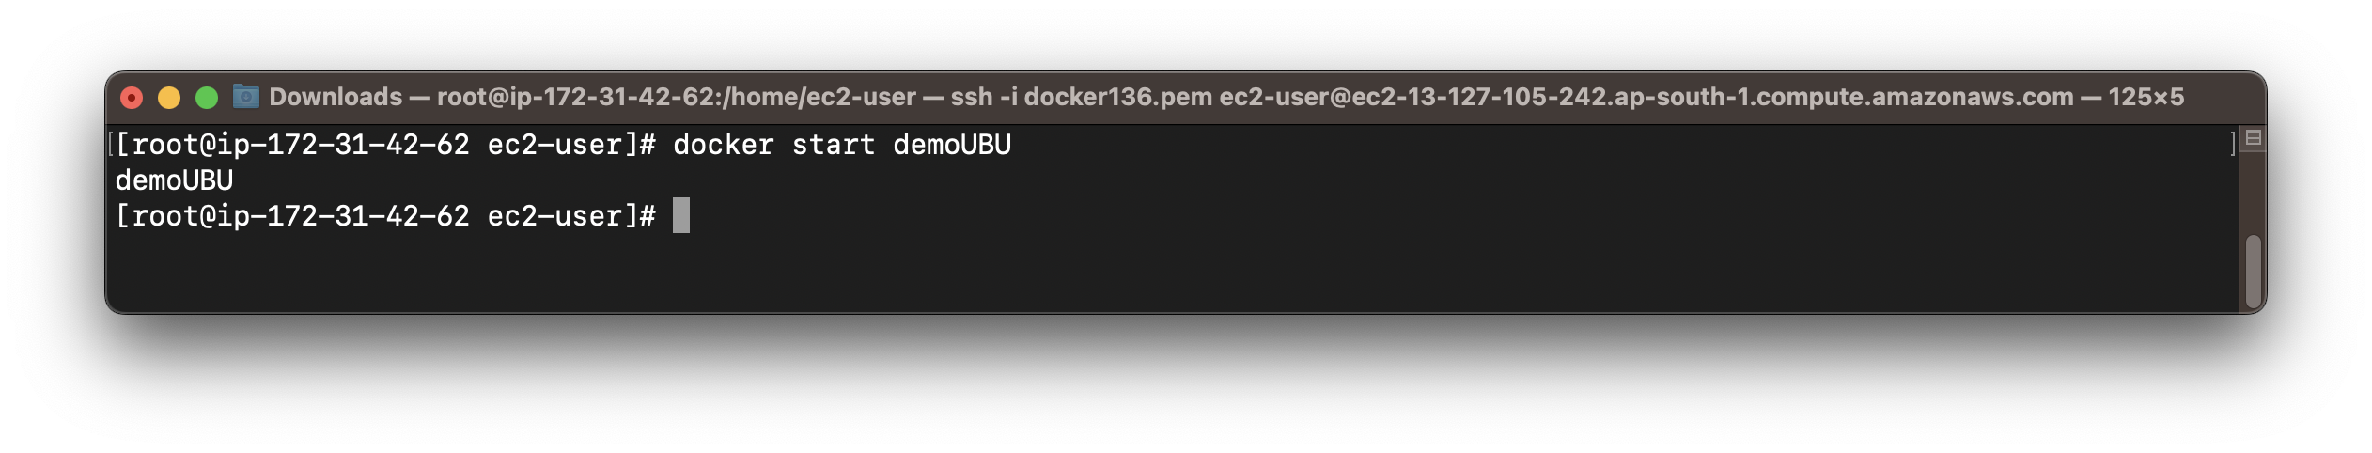

1. Attach Docker

*# docker attach demoUBU*

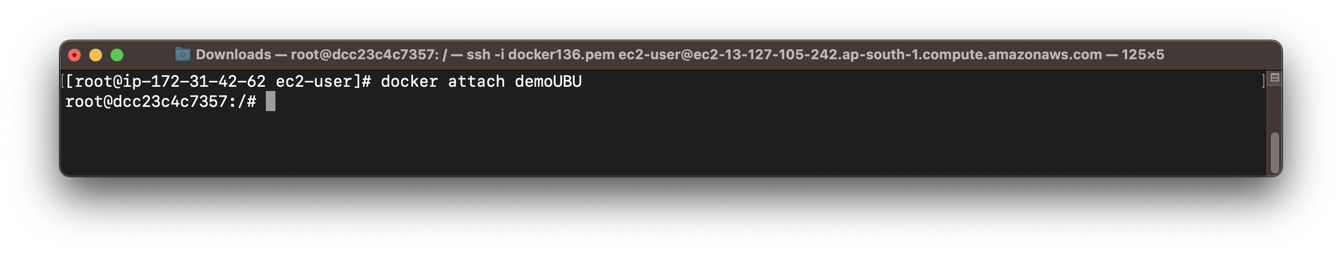

1. List Files and Directories in the Container

*# ls*

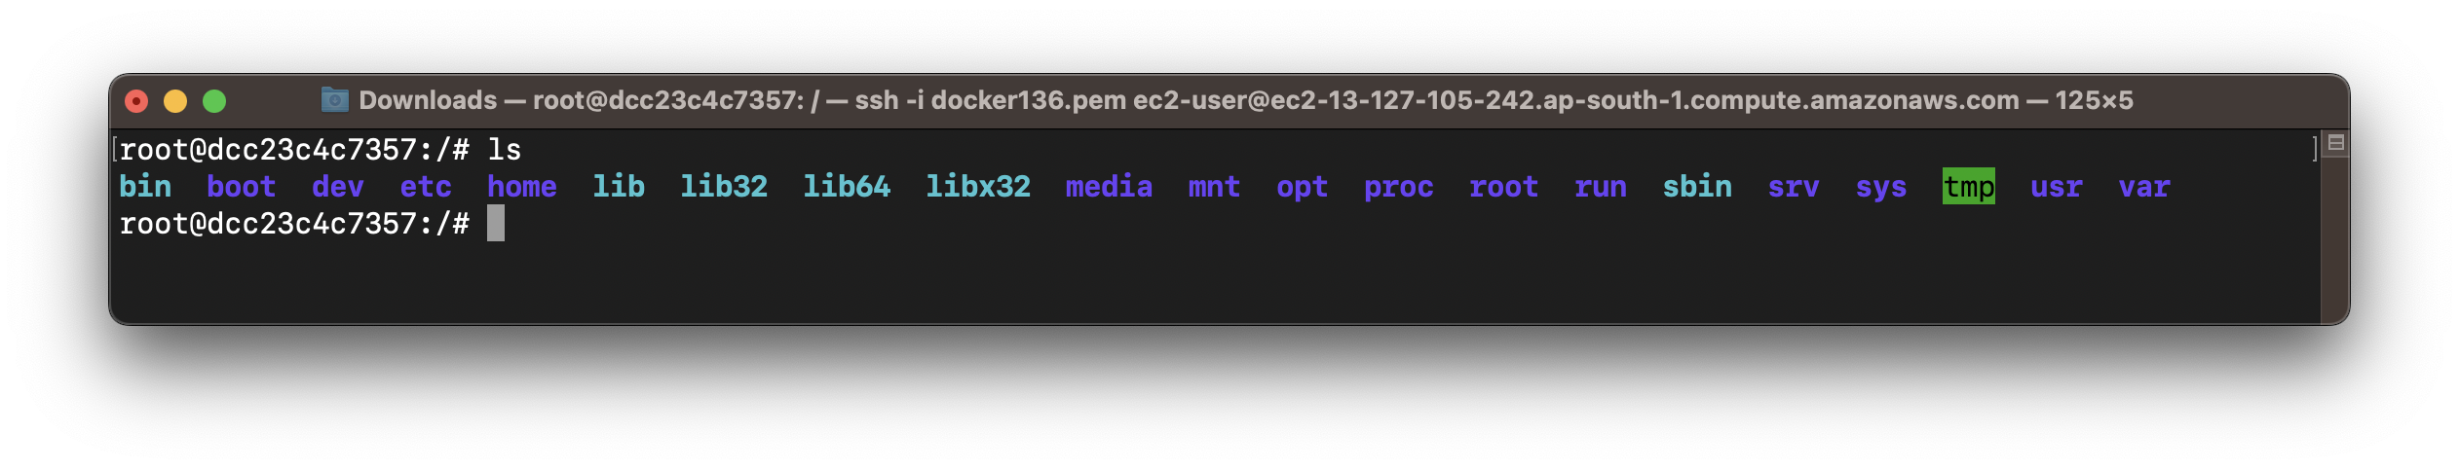

1. Create a file in the Container

*# cat > demofile.txt*

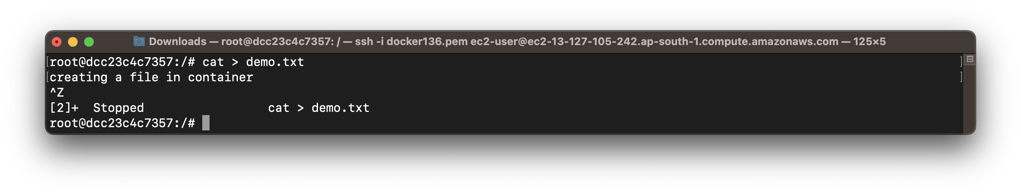

1. List all the files and directories in the current directory

*# ls*

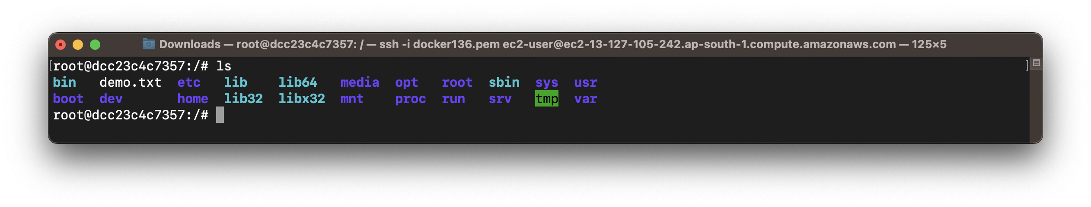

1. Update the package index files on the system, ie. Container

*# apt-get update*

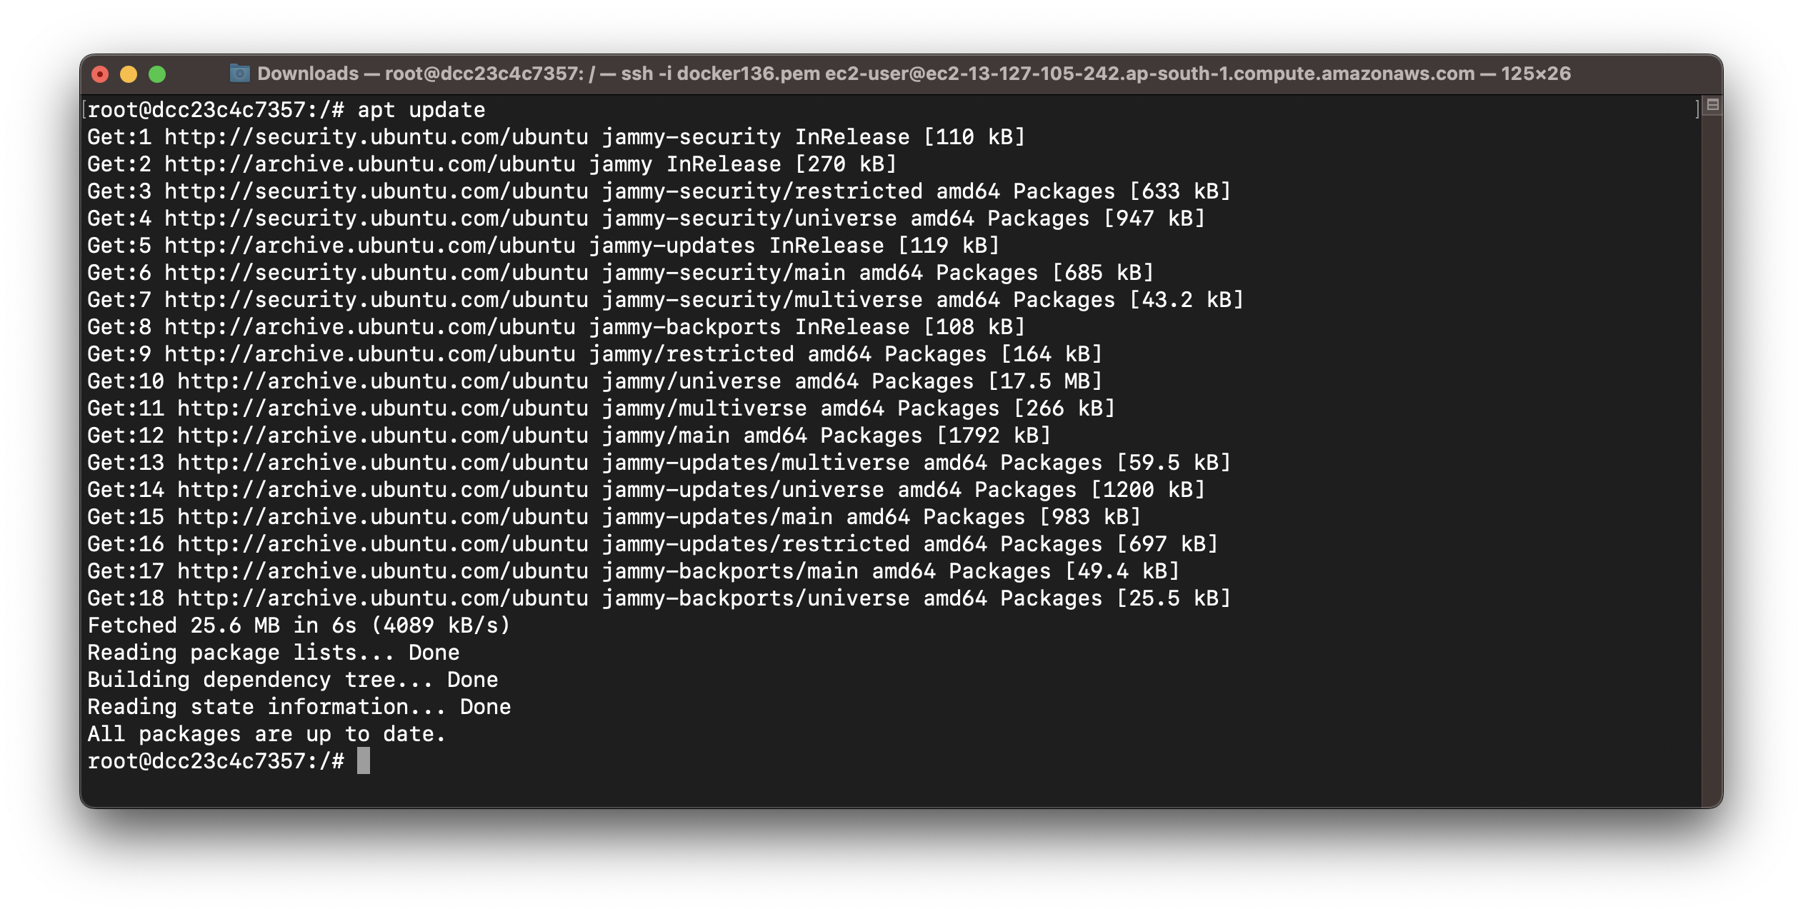

1. Install Apache in Container

*# apt install apache2*

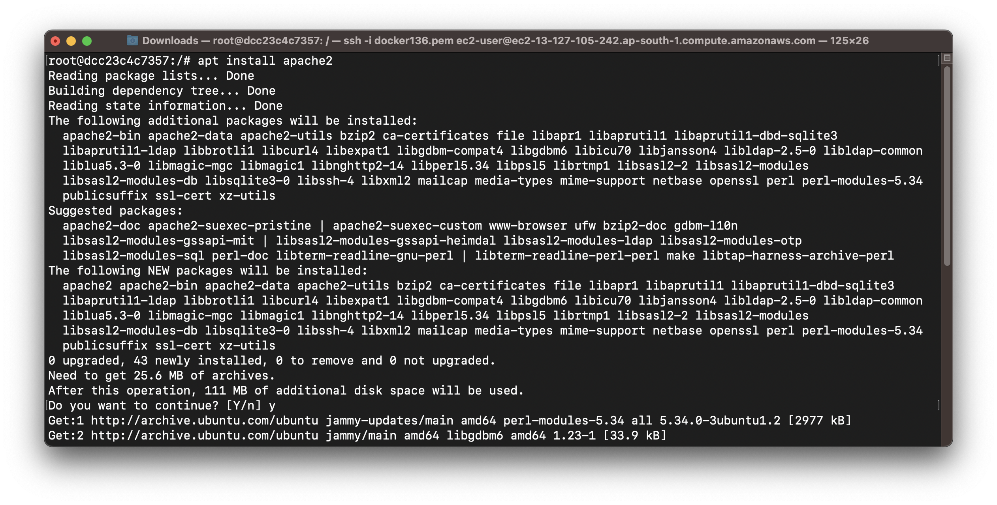

1. Display Apache Version

*# apachectl -v*

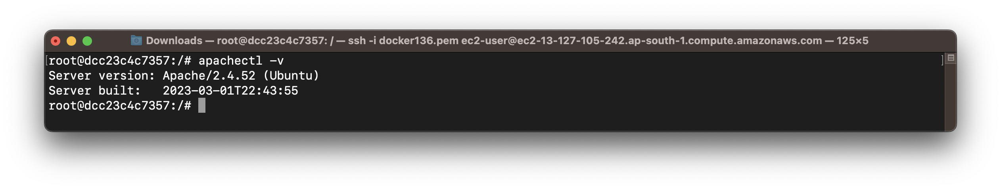

1. Install Tree in Container

*# apt install tree*

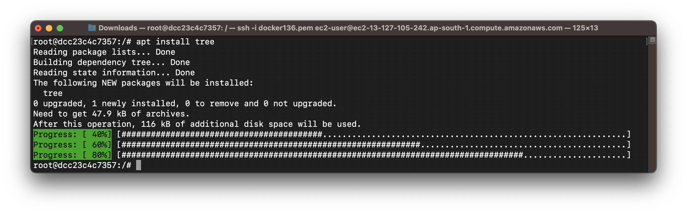

1. Dispaly Tree Version

*# tree –version*

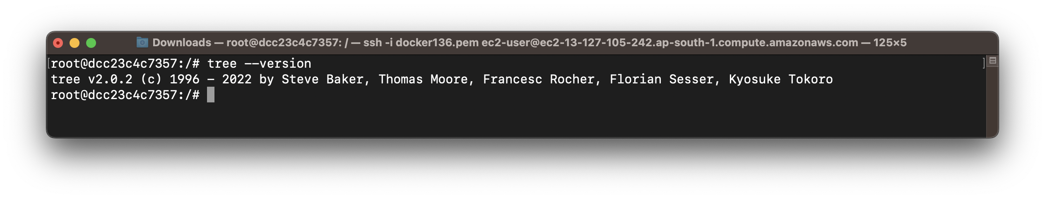

1. View directory using Tree

*# tree*

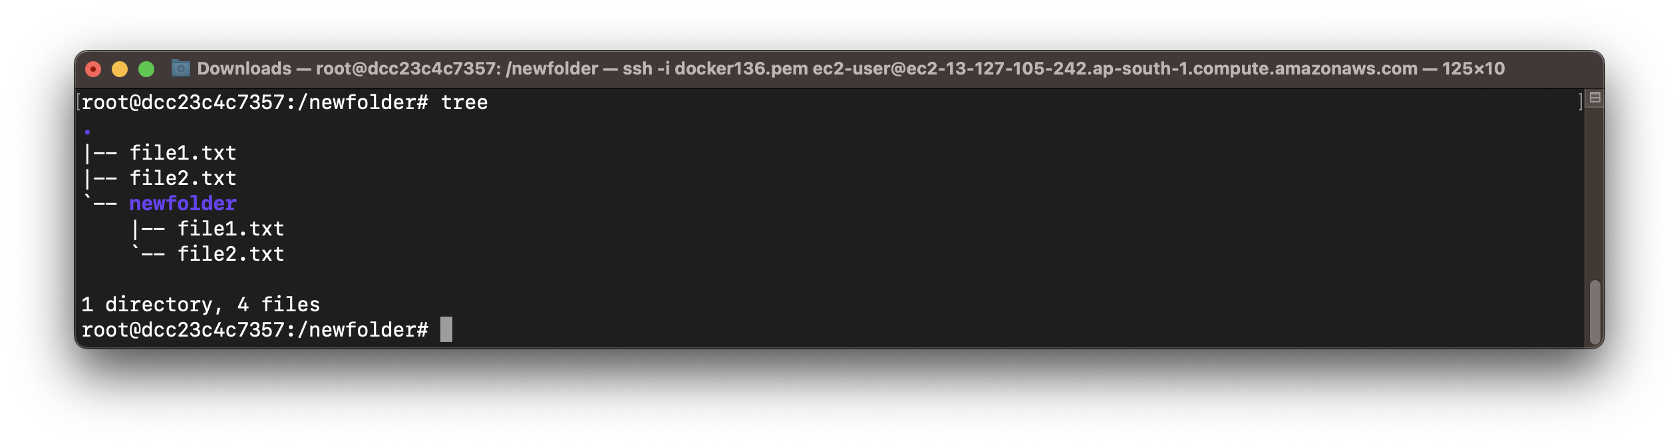

1. Install VLC in Container

*# apt install vlc*

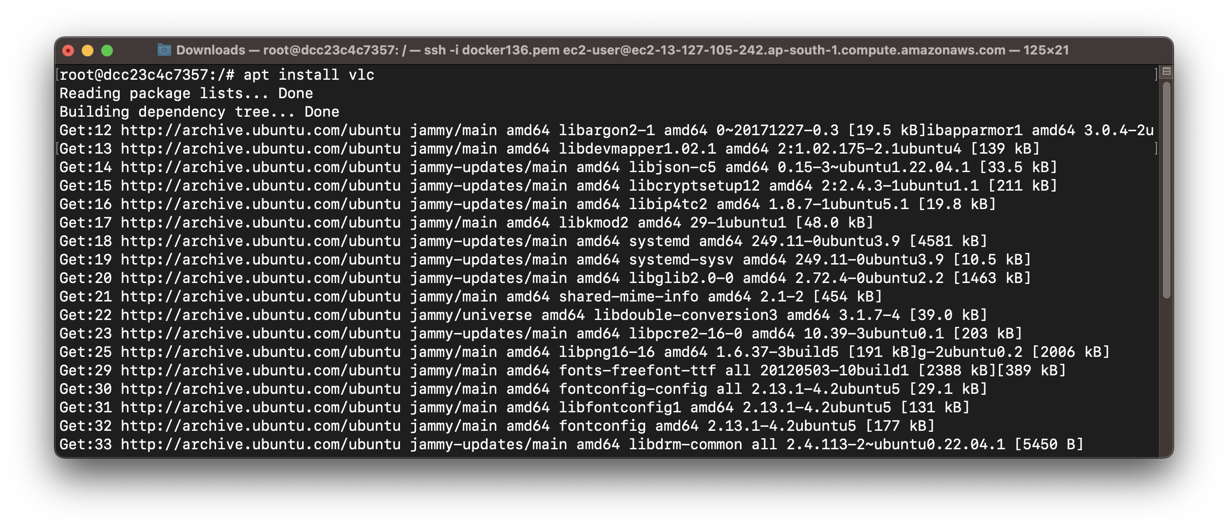

1. Check VLC directory

*# which vlc*

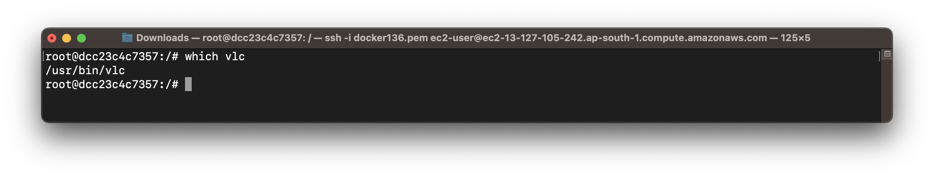

1. Rename Container

*# docker rename demoUBU UBUdemo*

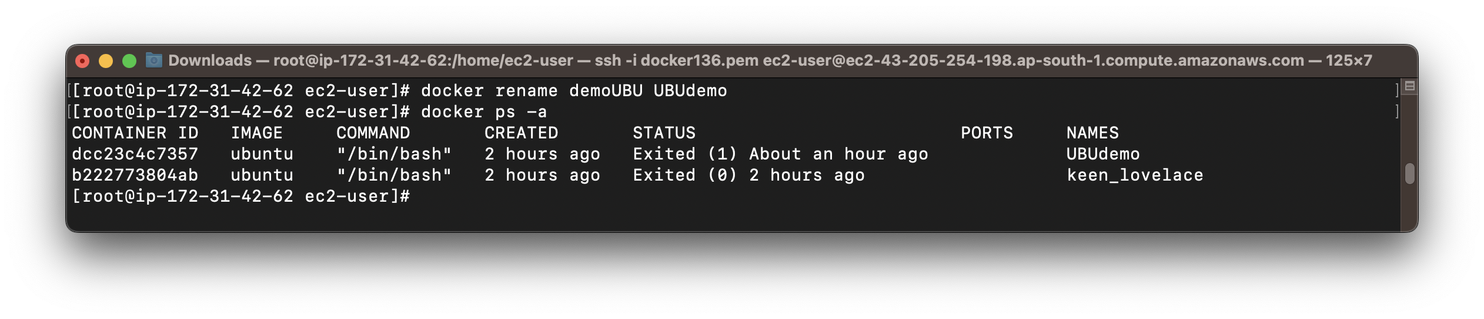

1. Create Docker Image

*# docker commit <container_name> <new_imagename>*

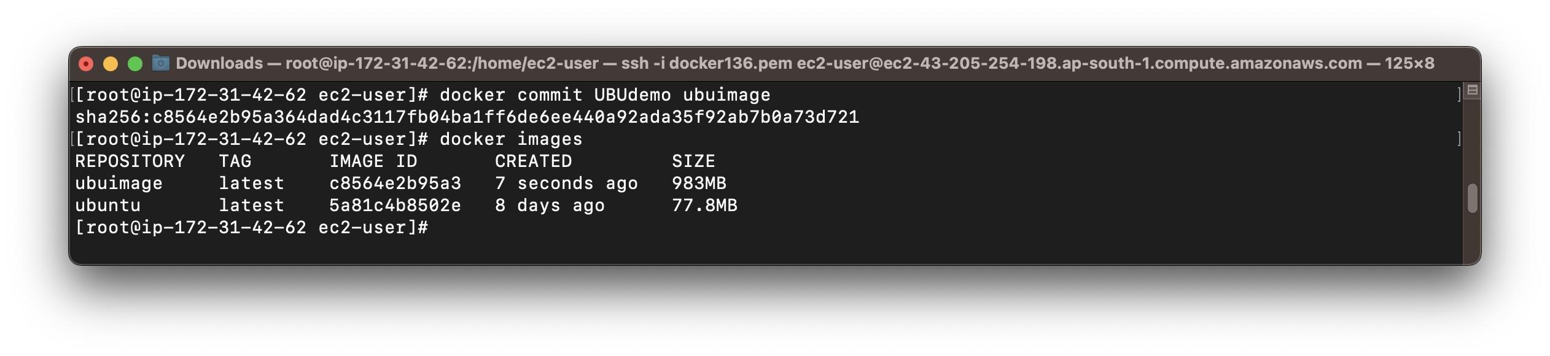

1. Create a Container using Docker Image created in previous step

*# docker run -it –name ubucontainer ubuimage /bin/bash*

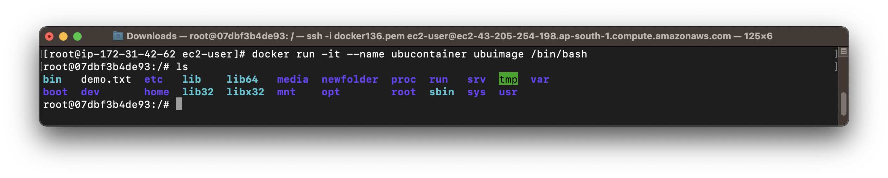

1. Push Docker Image to Docker Hub
2. Login into Docker Hub

*# docker login*

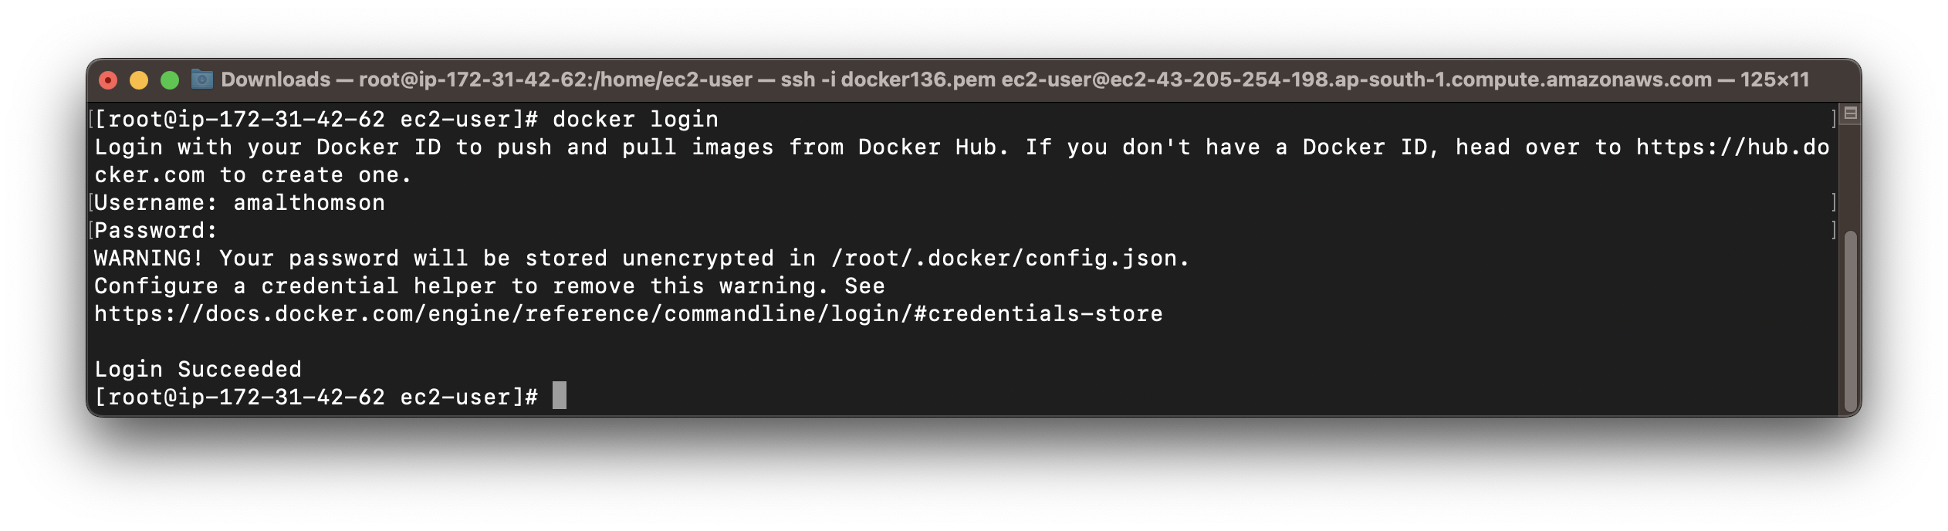

1. Tag Docker Image

*# docker tag ubuimage amalthomson/ubuimage1*

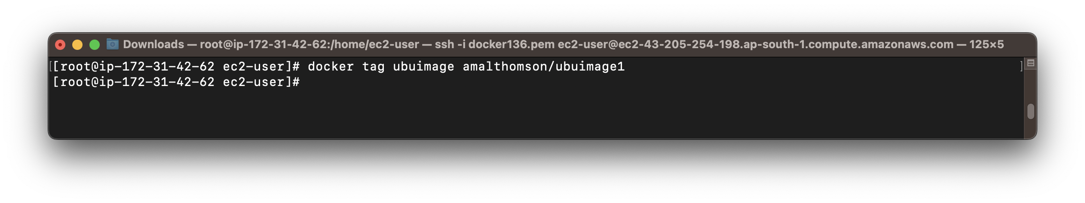

1. Push Docker Image to Docker Hub

*# docker push amalthomson/ubuimage1*

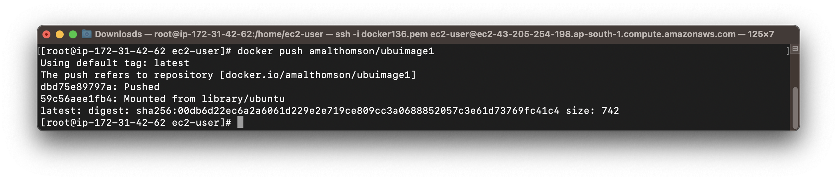

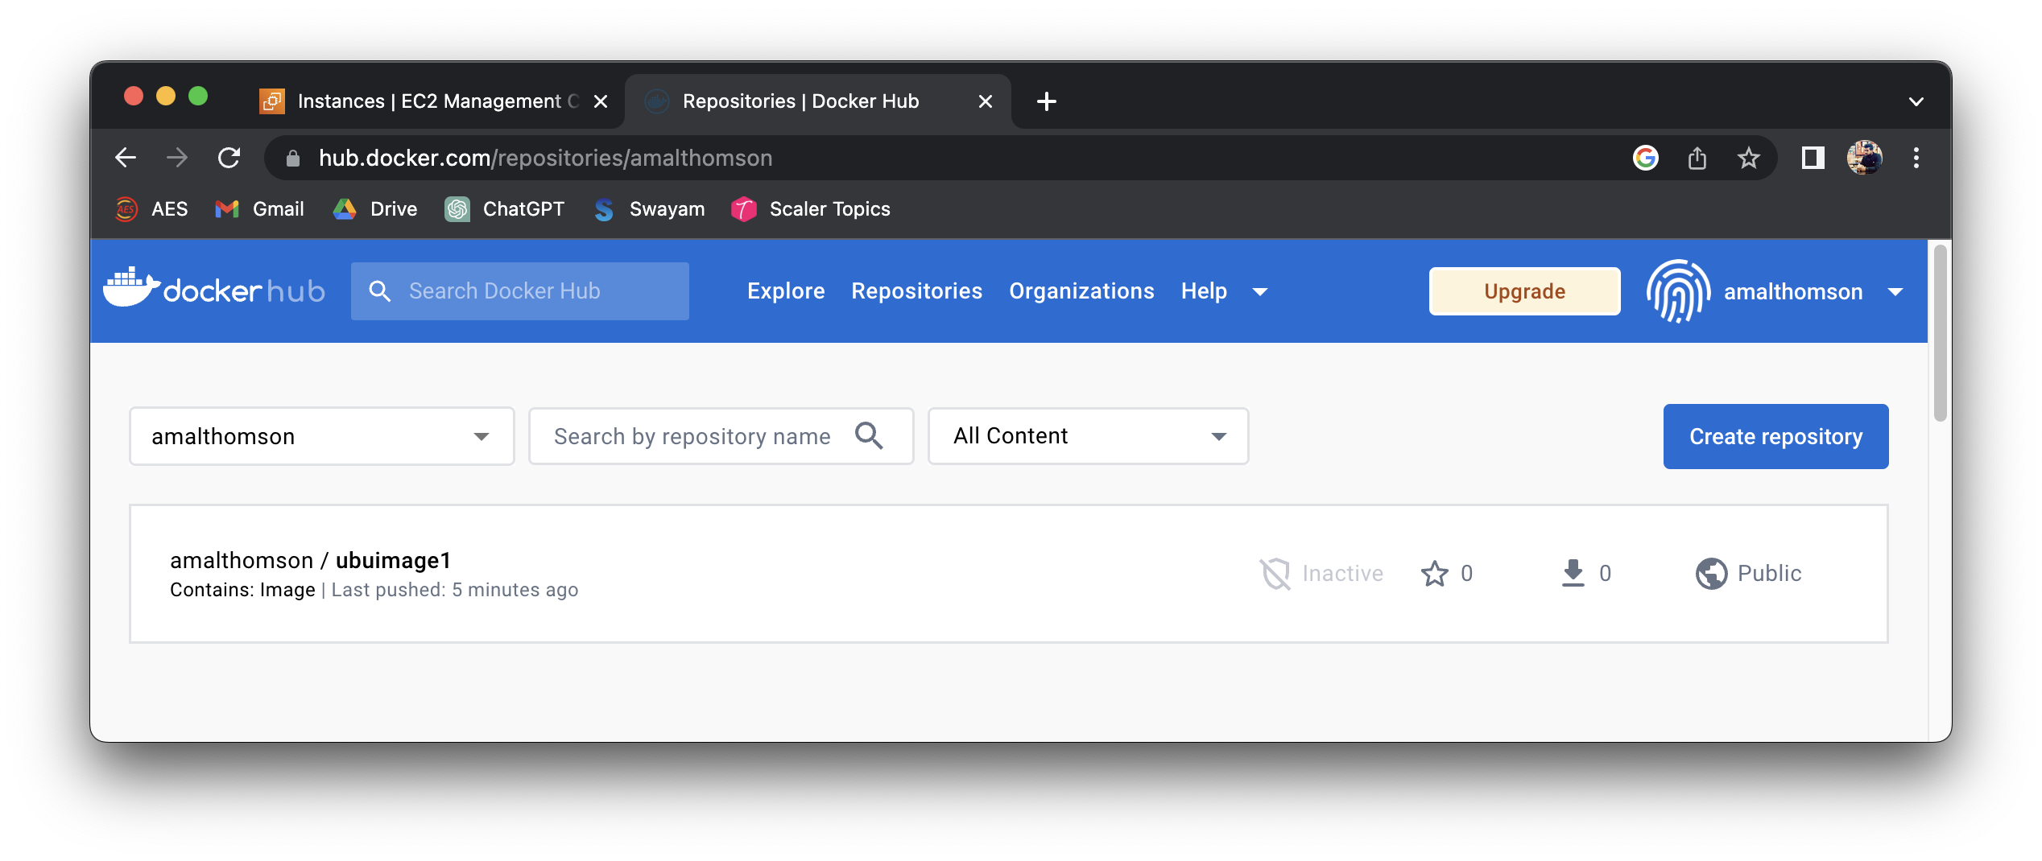

1. Pull the pushed Docker Image from another ec2 Instance – When Image is Public
2. Connect to the ec2 Instance (ap-southeast-1 : Singapore)

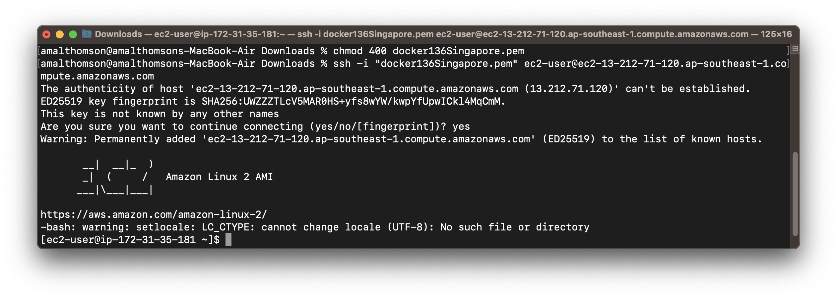

1. Install Docker and Start Service
2. Pull and Run Container using the Image from Docker Hub

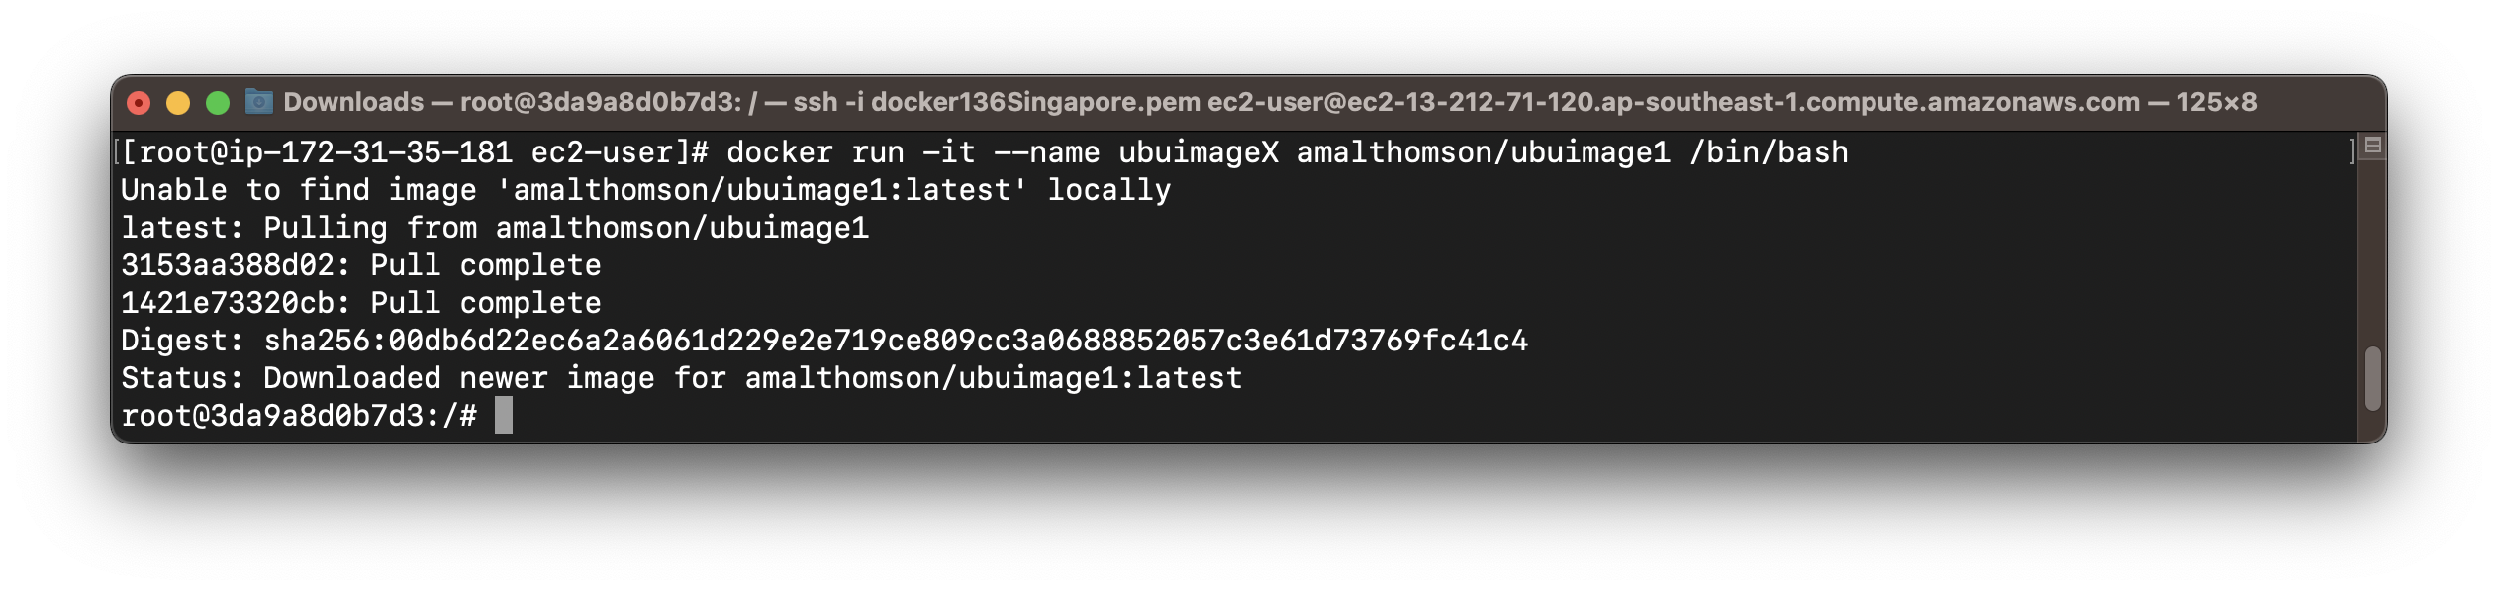

1. Display Images pulled from Docker Hub

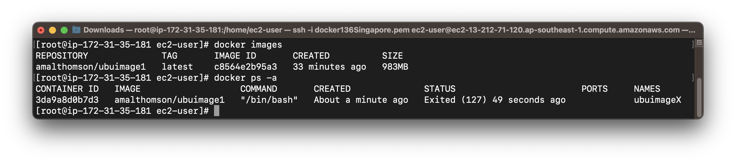

1. Pull the pushed Docker Image from another ec2 Instance – When Image is Private
2. Pull and Run Container using the Image from Docker Hub

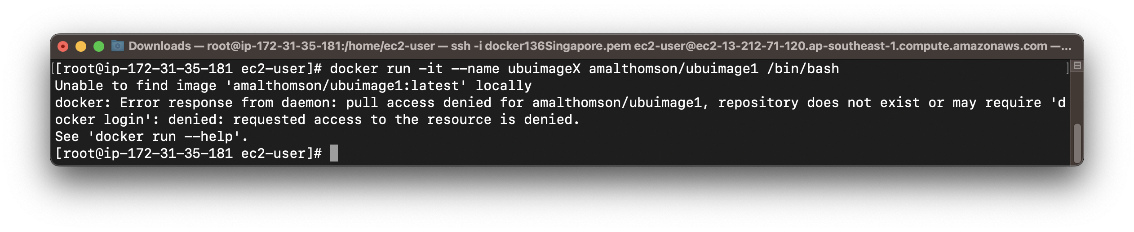

1. Login into Docker Hub

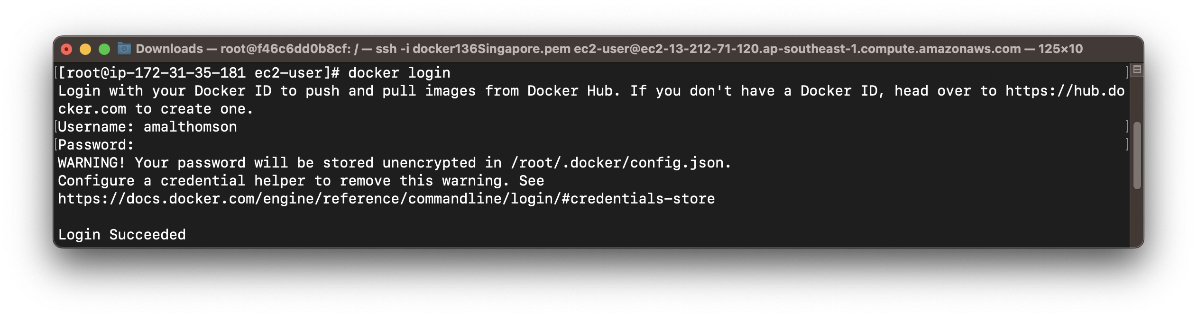

1. Pull and Run Container using the Image from Docker Hub

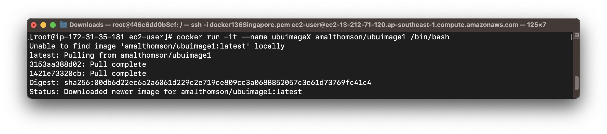

1. Display all Docker Images pulled from Docker Hub

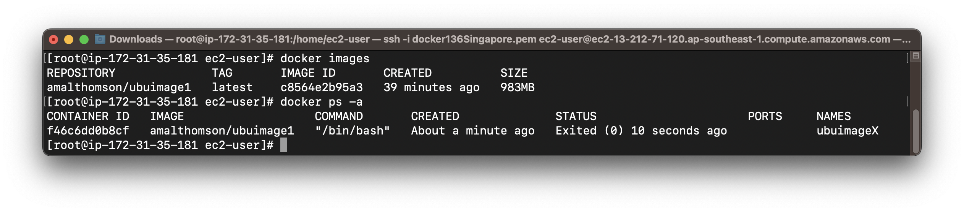

1. Exit Container

*# exit*

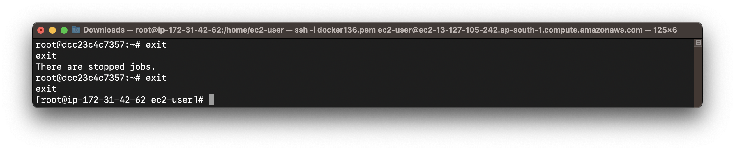

1. Delete Containers

*# docker rm <container_name/container_id>*

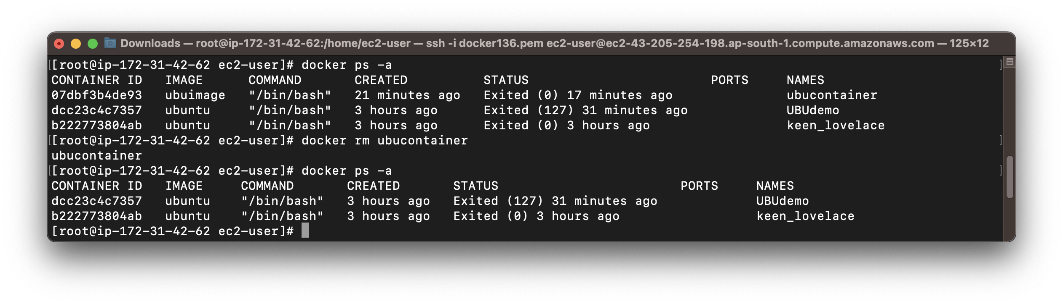

1. Delete Docker Image

*# docker rmi <dockerimage_name/dockerimage_id>*

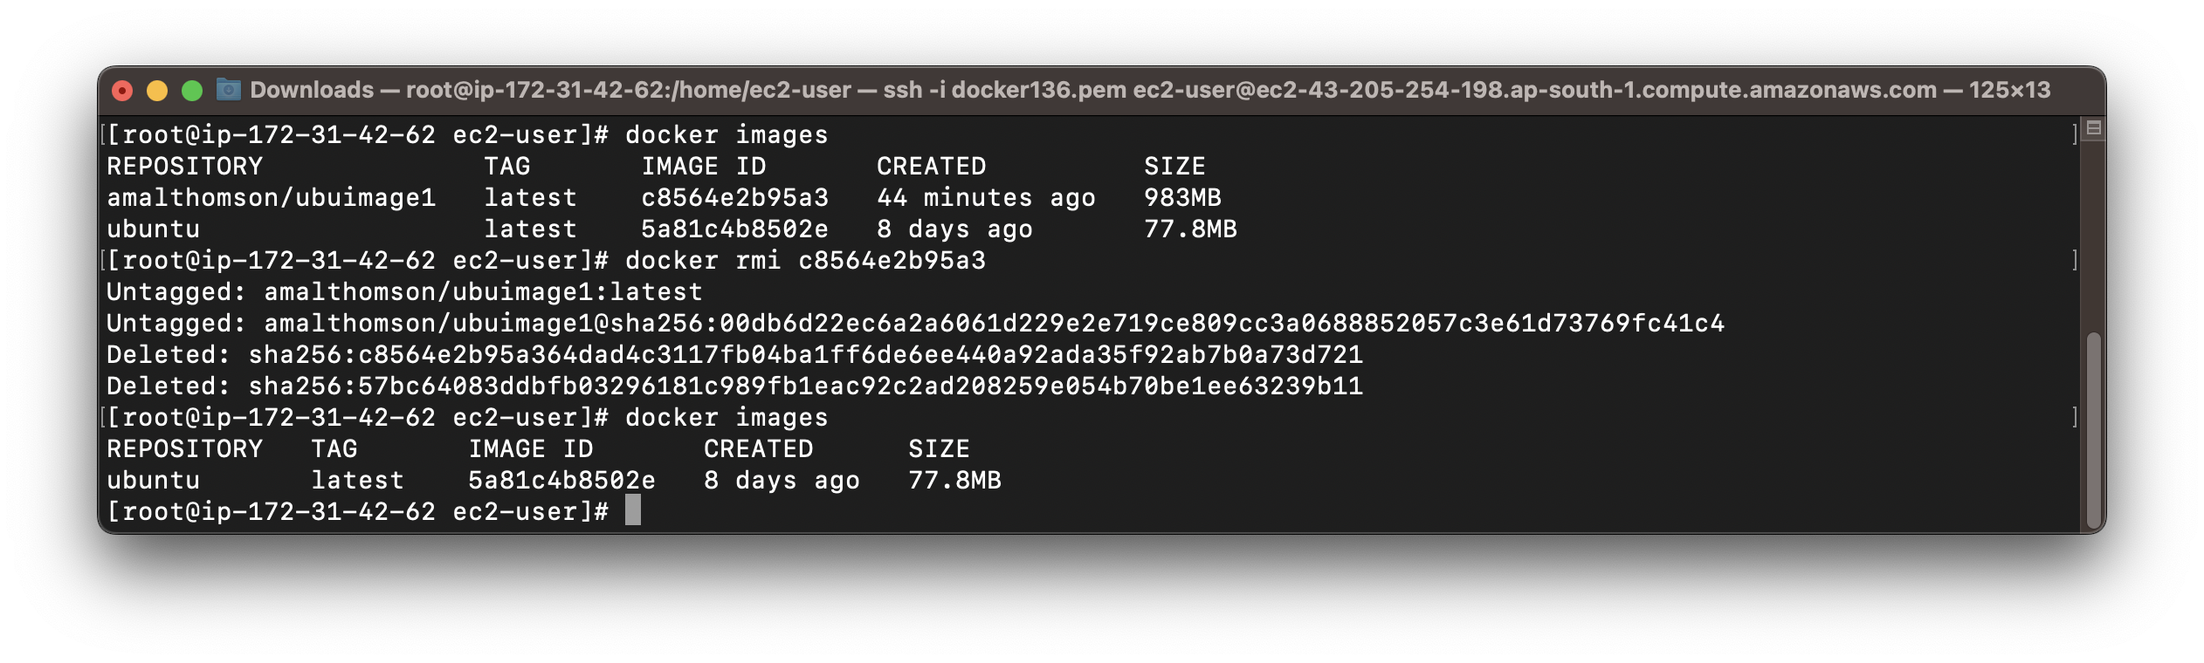

1. Exit EC2 Instance

*# exit*

